Dear customer, Thank you for your trust to our company (SHANDONG YUYING OPTICAL INSTRUMENT CO.,LTD)，In order to communicate easily and accurately between the two parties, please ask your technician to fill in the sheet patiently.

Customer name: Product model:
Date： customer confirmation:
I. Installation and use requirements

1.1.Wall mounted(see picture 1) Ceiling(see picture 2)
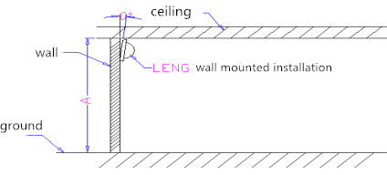 Wall mounted （picture1）
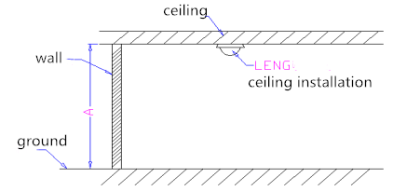
Ceiling(picture 2)
註： Remark：Wall mounted and ceiling design is different, generally not universal

1.2.Installation height meter（Plz see place A in picture 1 and picture 2（Installation height）），Desktop placement and doorbell are all wall mounts. Different installation height detection results are different., It is recommended that you fill in the exact value, the height range should not exceed 0.3 meters.
1.3.Product tilt when wall mounted degree Remark:：As shown in Figure 1, θ, the tilt angle will affect the detection effect, such as distance and angle

1.4.Background temperature ℃（Regular is 25℃±2℃）注：3. The background temperature directly affects the detection effect. The higher the temperature, the shorter the distance.

1.5.Product application scenario
II.Structural parameters
- Sensor数目

- Sensor .Please provide 3D drawings or line prototypes relative to the lens and product location.
Sensor Tilt angle is degree or Designed by YUYING （see picture 3）
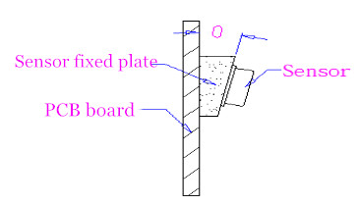
（picture3）

- Focal length is ＿＿ mm or Measured according to the actual customer supply. The focal length is the distance from the center of the probe to the top of the lens in front of the probe.

- After the lens is installed, it is flat(see picture 4) or Cylindrical surface(see picture 5)or Spherical（see picture 6）or Alien（see picture 7）
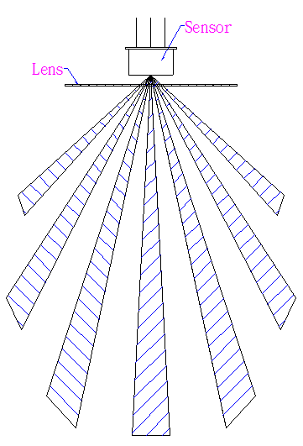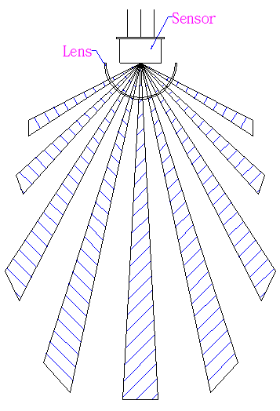
(picture 4)
(picture5)

（picture 6）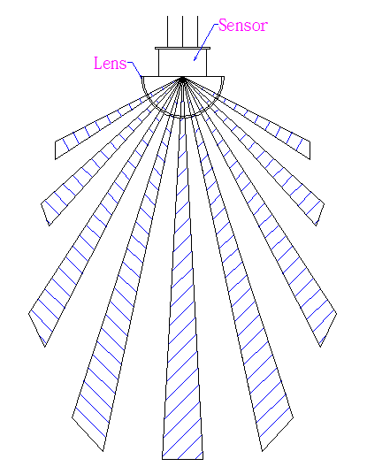 （picture7）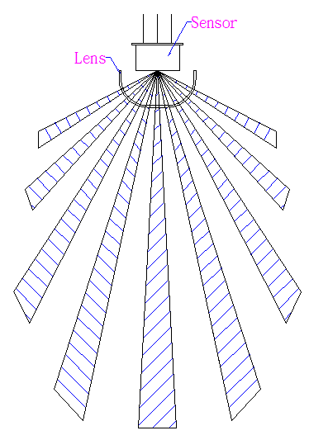
- Lens optical area size length: mm. width: mm or diameter is mm
Customers are advised to provide 3D drawings of housing, bracket and PCB board(Avoid interference with lens design)

III. The circuit design
- Sensor Brand: Model No: Remarks:：Different sensors, their parameters will affect the detection distance and angle

- What is the circuit magnification? Multiple

- other requirements：

IV.Detection requirement
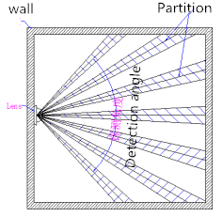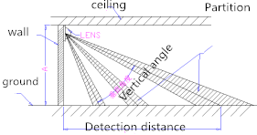
(picture9)
(picture10)

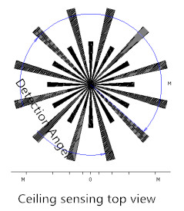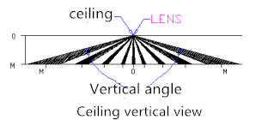
（picture8）
(picture11) 111111)

- Wall-mounted detection horizontal angle and distance： degree ＿＿＿ m (see picture 8)
- Wall-mounted detection vertical angle and distance： ＿＿ degree m (see picture 9)
- Ceiling detection top view angle and distance： ＿＿＿ degree ＿＿m （see picture 10）
- Suction detection vertical angle and distance： degree m （see picture 11）
- Testing according to industry standards
- Customer additional sensing needs（Fill in according to the actual application scenario: such as micro-action, anti-white light and anti-pet, etc.）

(The optical part partition is designed by Yuying. The lens is designed according to the customer's intention to meet the customer's demand angle and distance parameters. It is recommended that the customer provide the prototype or PCB board.)

V.Other requirements
- UV resistant design YES¨ NO¨ （ ____ year）remark：Please specify the specification
- Product colour primary color¨ white¨ black¨ Swatch¨ others¨

